Module 01 Lab – Introduction to Lamp VMs

Jessica J. Scharber

Rasmussen College

Module 01 Lab – Introduction to Lamp VMs

The following text and images document the process of configuring my development environment in Microsoft Azure. This project will also showcase the connection to phpMyAdmin and the copying of the AdventureWorks database.

# Creating a Storage Account

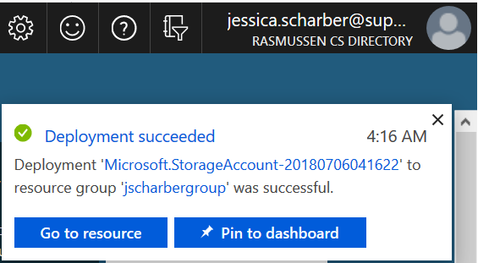

Configuring the Virtual Server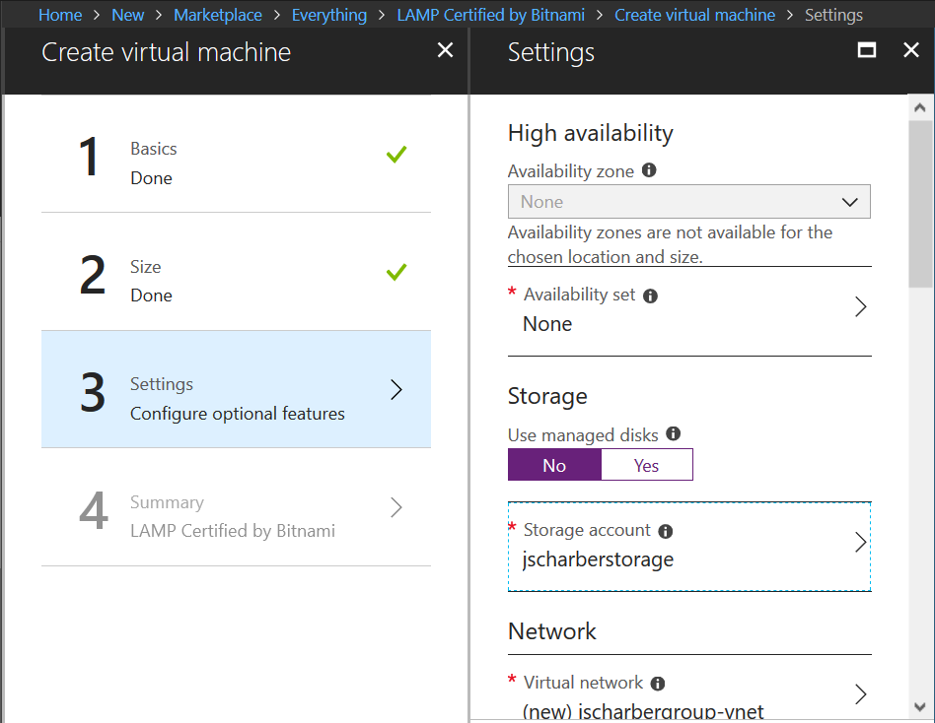

# **Deploying the Lamp VM**

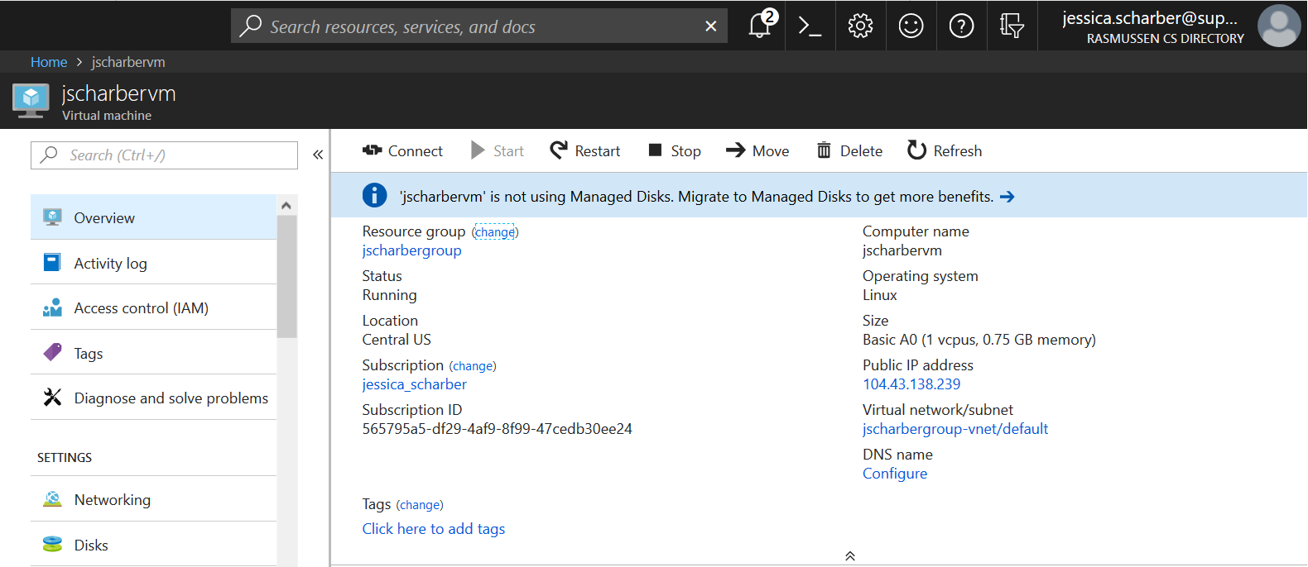

# Connecting to the Virtual Server Using SSH

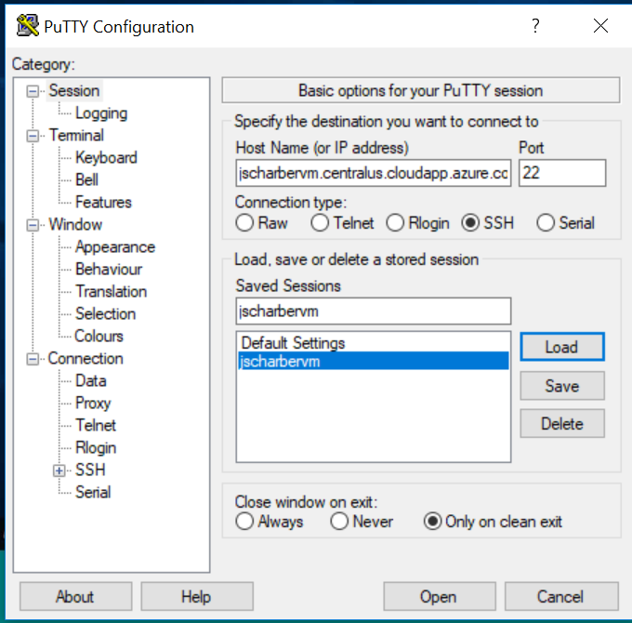

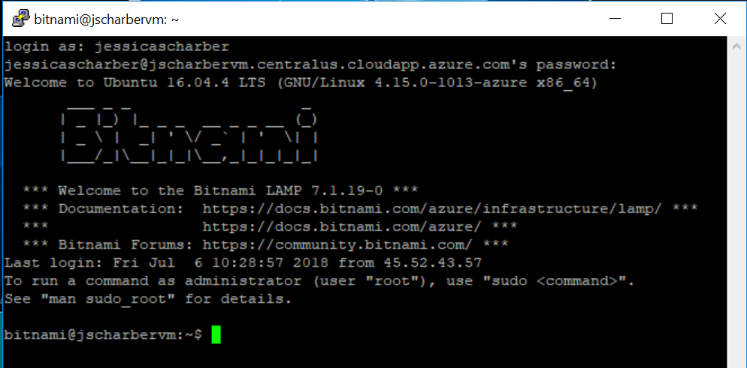

# Connecting and Viewing phpMyAdmin

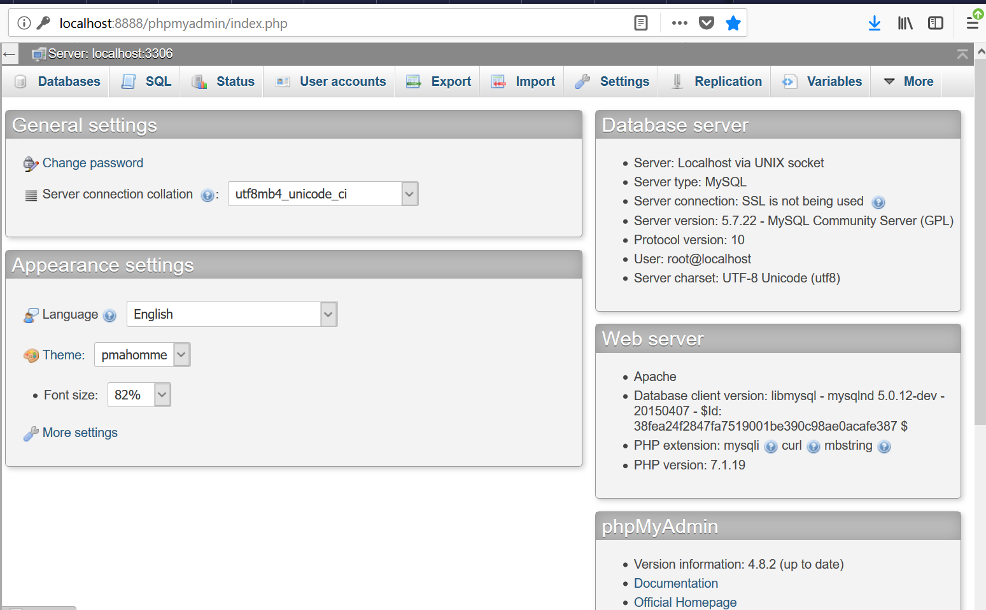

# Copying the AdventureWorks Database

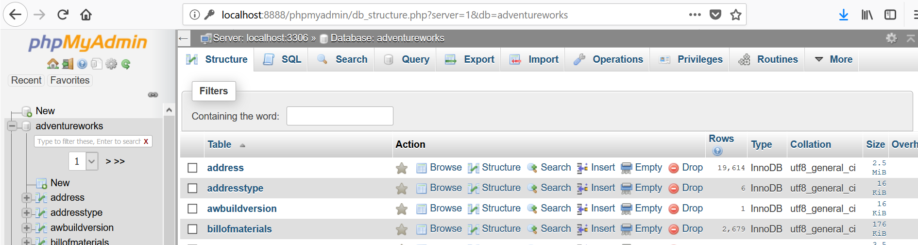

# URL of FQDN

jscharbervm.centralus.cloudapp.azure.com